CSA 283: Final

Name: ______________________________________ Section: _____ _____

Please write legibly. Ask questions if something is unclear. Write down any assumptions you make.

Some useful formulas:
d_{trans} = L/R d_{prop} = d/s

- Consider the network diagram shown in the supplemental handout. The diagram depicts the following:

- Four end systems labeled A, B, C, and D
- Two switches labeled S1 and S2 (Switch interfaces for each switch are labeled 1 – 3)
- Five routers labeled R1, R2, R3, R4, and R5 (The interfaces of R2 are labeled 1 – 3)

Information held at various nodes is given on the page following the diagram.

In the following questions consider a message being sent from host A to host D and the segments, packets, and frames that will be generated to carry the message.
- The socket on A that is being used to send the message has a port number of 2200.
- The port number of the socket being used on D to receive the message is 53.

Use the diagram and tables contained in the supplemental handout to answer the following questions.

    - What will the destination physical address be in the frame that travels from A to R1? (2 points)

    - Based on the ARP table of A, can A construct a frame and send it to R1? Describe the sequence of events that must take place before the frame can be built (6 points).

    - After A has sent the frame to R1 will the switch table for S1 be modified? If so how? (4 points)

    - Will the network interface adapter of B receive the frame that is sent by A to R1? Why or why not? (4 points)

    - What will be the source IP address and port number in the packet/segment that travels between A and R1? (4 points)

    - What will be the destination IP address and port number in the packet/segment that travels between A and R1? (2 points)

    - What will be the source IP address and port number in the packet/segment that travels between R1 and R2? (2 points)

    - What will be the destination and source MAC addressed be in the frame that travels between R1 and R2? (2 points)

    - Based on the forwarding table given for R2, will it forward the packet to R3 or R4? (4 points)

    - Will the frame that is sent from R5 to D be seen by network interface adapter of C? Why or why not? (4 points)

    - After R5 has sent the frame to D, will the switch table for S2 be modified? If so how? (4 points)

    - Suppose A and D are using UDP. Will D be able to receive messages from B using the same socket that it is using to receive messages from A? (2 points)

    - When D sends a reply back to A, what will the destination IP address and destination port number be in the packet/segment that travels between C and R5? (4 points)

    - How could D use ARP to get the MAC address of A? (4 points)

    - Give the Classless InterDomain Routing (CIDR) notation for the subnets identified by forwarding table of R2. Indicate approximately how many hosts each sub-net could contain. (6 points)

CIDR notation Approx. Number of Hosts

________________________ __________

________________________ __________

________________________ __________

- Write the internet protocol layer to which each of the protocols below belongs.
(12 points)

SMTP _______________

IP _______________

Ethernet _______________

UDP _______________

HTTP _______________

TCP _______________

Assume routers are identified by upper case letters and subnets are identified by lower case letters.

The neighbors of a router are one hop away.

The following is the routing table at router D:

Destination Subnet | Next Router | Number of Hops to Dest.
w | A | 5
y | C | 5
z | B | 3
x | - | 7
r | A | 2
… | … | …

Assume that router D receives the following advertisement from neighbor A:

Destination Subnet | Next Router | Number of Hops to Dest.
z | C | 4
w | - | 1
x | E | 3
u | F | 6

As a result of the above advertisement, D may (or not) change its routing table. Show D’s updated routing table below: (12 points)

Destination Subnet | Next Router | Number of Hops to Dest.

- A group of received TCP segments has the following characteristics.

TCP Sequence Number | Bytes of Data | Acknowledgment number  sent by receiver
1000 | 300
1600 | 300
1900 | 300
2800 | 300

Assume the initial sequence number of the first segment to carry data was 1000. Are there any gaps in the data received? If there are gaps, indicate by “byte numbers” the ranges of bytes that are missing: (6 points)

Complete the table by filling in acknowledgment number that would be carried in the receivers reply to each segment. (8 points)

- In a reliable connection oriented protocol such as TCP, what is the primary mechanism (sequence numbers, checksums, timers, ect.) that allows the protocol to deal with each of the following types of errors? (8 points)

Out of order segments _______________

Lost segment _______________

Corrupted segment _______________

Duplicate segments _______________

- Use the constants below to answer the following questions. Show work for partial credit. Indicate the units for each answer. Show times to four decimal places. Assuming processing and queuing delays are negligible.

File Size 45 Mb
Packet Size 1.5 Mb
Link Bandwidth 30 Mbs
Link Lengths 30 Kilometers
Propagation Speed 2.8 x 10⁵ Kms

- What is the bit time for the parameters given? (2 points)

- Calculate the propagation delay for a single link. (2 points)

b. Calculate the transmission delay for a single packet and a single router.
(2 points)

- Assuming there are five links connected by routers as depicted below. If processing and queuing delays are negligible, how much time will be require for a single packet to travel from A to B. (3 points)
A
B

d. Again assume and queuing delays are negligible. For pipelined transmission with a transmission window of infinite size, calculate the time needed for the entire file to travel from A to B. (6 points)

- Consider the following scenario:

A mail server running on mail.uc.edu wants to transmit email for oscar@npr.org. In the following, assume that all nodes including mail.uc.edu cache DNS records. All DNS caches are initially empty. The first query sent by mail.uc.edu is handled recursively. Assume all other queries are handled iteratively. DNS server names are as follows:

TLD DNS server, edu: dns.tld.edu
TLD DNS server, org: dns.tld.org
Local DNS server, uc: local.uc.edu
Local DNS server, npr: local.npr.org
Authoritative DNS, npr: dns.npr.org
Authoritative DNS, uc: dns.uc.edu
Root DNS server: dns.root

- Draw arrows labeled with numbers to indicate the order of queries and responses sent before mail.uc.edu receives the IP address of mailfwd.npr.org. (8 points)
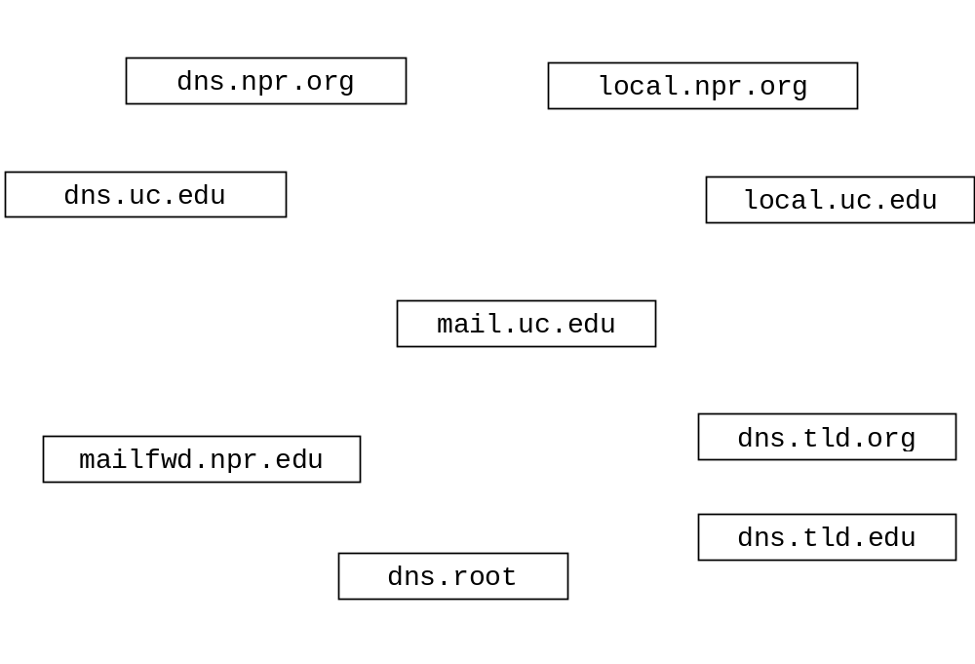
- After the sequence in part a. has occurred, suppose mail.uc.edu wants to upload mail for fred@npr.org. How would the sequence of events be different? (3 points)
- Briefly describe when fast re-transmit occurs and why. (4 points)

- Identify which of the following protocols use a client/server architecture and which use peer to peer architecture by circling the correct answer for each.
(4 points)

HTTP: client/server peer to peer

FTP: client/server peer to peer

SMTP: client/server peer to peer

DNS: client/server peer to peer

- Complete the Server on the next page. Do not worry about handling exceptions. Allow the main method to throw all exceptions to the OS.
(24 points)
- Clients contact the Server and send one UDP segment containing up to 100 floats (a float is four bytes).
- The Server determines the number of floats actually received, calculates the product of the floats, and sends the product back to the client as a float via UDP.
- When the Server receives an empty packet containing no data, the server itself will close without sending any response to the client.
- Otherwise the server will wait to receive additional packets and respond to other clients.
- The Server listens for clients on port number 9999.
- Do not use multi-threading. The server only needs to handle one client at a time. The Server handles clients sequentially.

import java.io.*;
import java.net.*;

public class ProductServer {

public static void main(String[] args) throws Exception
{

